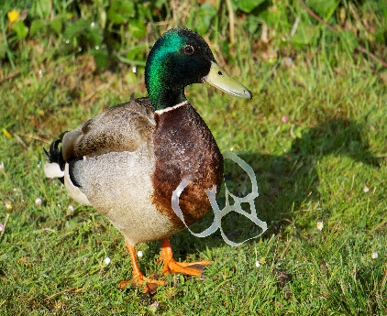
GREAT BRITISH SPRING CLEAN & LITTER PICK

This Photo by Unknown Author is licensed under CC BY-SA

Badwell Ash Parish Council will be taking part in this event on Saturday 15 April from 10.00 to 12.00.
Badwell Ash meeting point will be at the Village Hall.
Long Thurlow meeting point will be at the Bus Shelter.
Litter picking equipment will be provided but please bring your own gloves.
All volunteers, both young and old, are welcome and the Parish Council would be grateful for the support to keep our villages clean and tidy.
Thank you :-)

