Badwell Ash Village Hall
FRIDAYS

Open every FRIDAY from 10.00 until 14.00 - FREE
WARM
Offering an inclusive welcome to everyone in the community

- Whether for just a cup of coffee, a snack or a cup of soup and a roll for lunch
- Please do come and join us for just as long as you wish
- Newspapers, magazines, books, games, playing cards and good company also provided!

FREE WARM WELCOMING SPACE

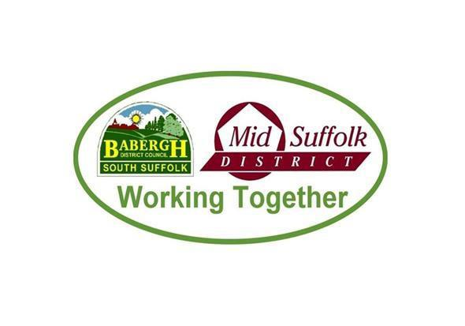
Sponsored by Mid Suffolk District Council
From 2 December 2022 through until 31 March 2023

